Hanging T-Shirts

Materials Needed:
- 4 Hangers
- 4 T-Shirts
- Area to Hang T-shirts Up.
- Task Analysis (Inserted Below)
- CLC VIDEO

Introduction/ Discussion:
Hanging T-Shirts is a Great life skill to practice while it increases and strengthens your child’s fine motor skills, concentration and attention to task. This allows students to be independent in developing those skills with confidence.

Activities:
- Placing T-Shirts on Hangers Properly
- Put Shirt on Hanger one at a time & placing them on Rack/Closet

Task analysis to hang a shirt

Hold shirt by collar

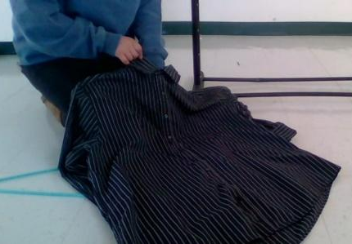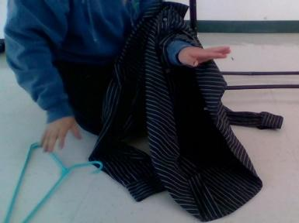

Hold hanger with hand in the shirt and pull up
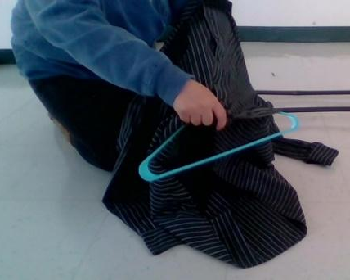

Stick your hand in the collar & out the bottom
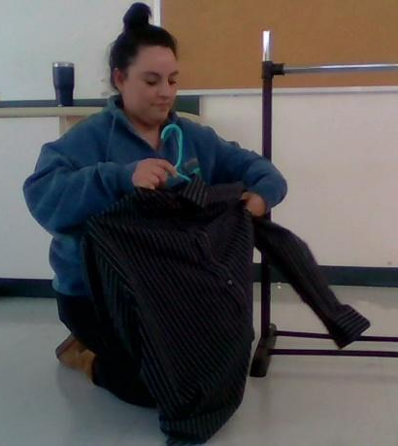

Gently pull the sleeves down to straighten the shirt

